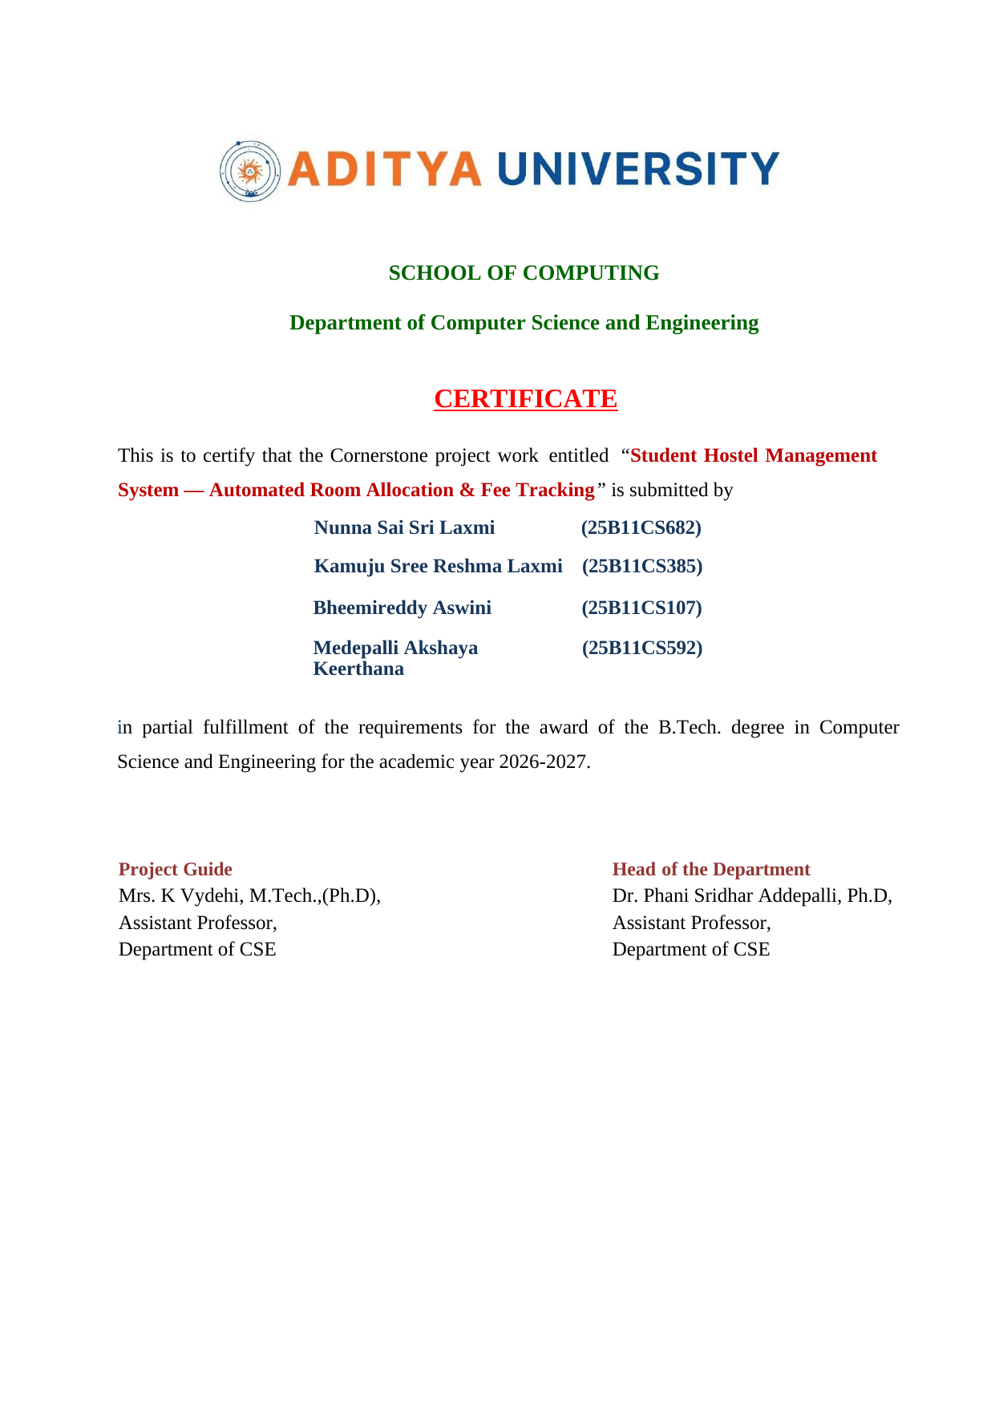
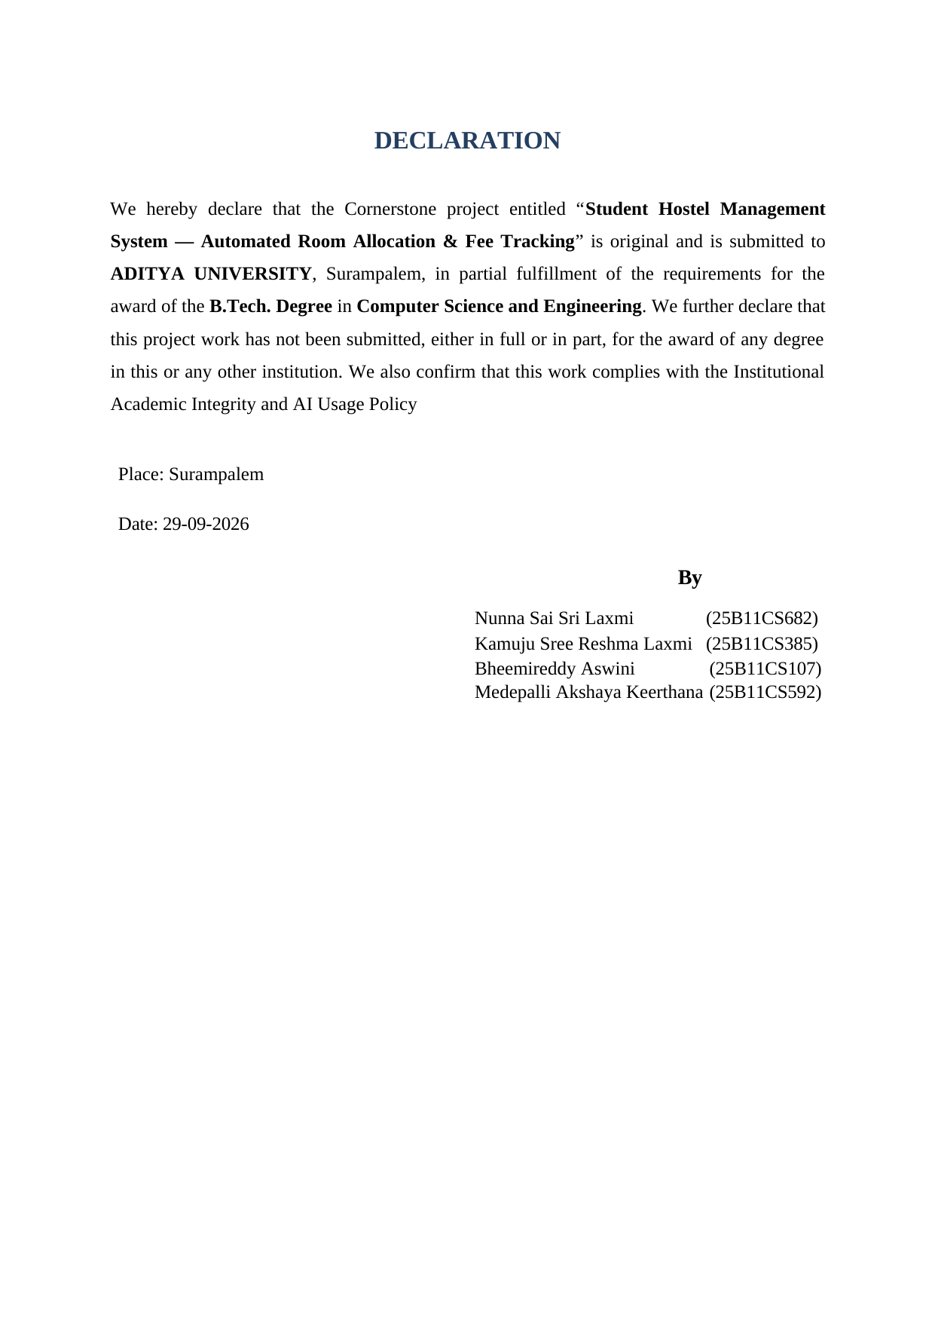
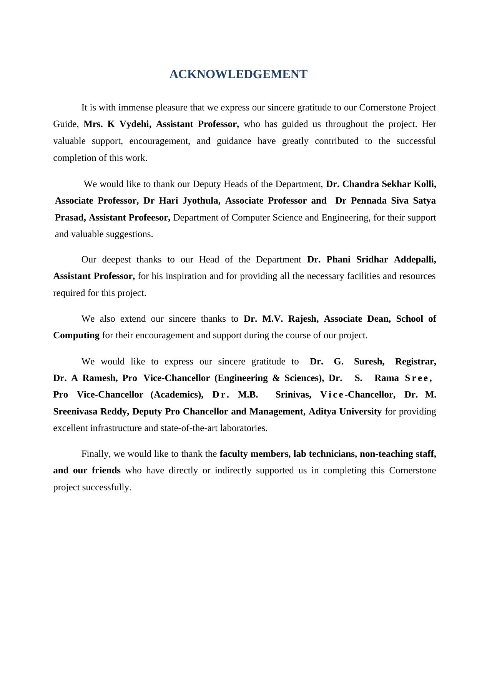

TABLE OF CONTENTS

S.No. | Chapter | Page No.
1 | Abstract | 8
2 | Introduction | 9
3 | System Analysis | 10
4 | Database Design | 12
5 | ER Diagram | 14
6 | Relational Schema | 15
7 | Table Design | 16
8 | Normalization | 19
9 | SQL Implementation | 23
10 | SQL Queries and Outputs | 28
11 | Conclusion | 32
12 | Future Enhancements | 32
13 | References | 33

LIST OF FIGURES
Figure | Page No.
Figure 1. ER representation of the Student Hostel Management System | 14

LIST OF TABLES
Table | Page No.
Table 1. Major entities and their purposes | 12
Table 2. Relationships and cardinalities | 12
Table 3. Relational schema | 15
Table 4. WARDEN table structure | 16
Table 5. ROOM table structure | 16
Table 6. STUDENT table structure | 16
Table 7. FEE_PAYMENT table structure | 17
Table 8. COMPLAINT table structure | 17
Table 9. VISITOR table structure | 17
Table 10. UNF sample rows | 19
Table 11. Anomalies in the UNF relation | 19
Table 12. Student before 1NF | 19
Table 13. Student_Phone after 1NF | 20
Table 14. Fee_Detail before 2NF | 20
Table 15. Student after 2NF | 20
Table 16. Fee_Payment after 2NF | 20
Table 17. Room before 3NF | 21
Table 18. Room after 3NF | 21
Table 19. Warden after 3NF | 21
Table 20. Flat vs final 3NF schema | 22
Table 21. Sample SQL query outputs | 28–31

ACRONYMS
DBMS – Database Management System
ER – Entity Relationship
SQL – Structured Query Language
DDL – Data Definition Language
DML – Data Manipulation Language
DQL – Data Query Language
DCL – Data Control Language
TCL – Transaction Control Language
PK – Primary Key
FK – Foreign Key
UNIQUE – Unique Constraint
1NF – First Normal Form
2NF – Second Normal Form
3NF – Third Normal Form

1. ABSTRACT
The Student Hostel Management System is a centralized relational database designed to manage hostel operations such as student registration, room allocation, fee payment tracking, complaint management, and visitor records. The supplied project identifies common problems in manual hostel administration, including room allocation errors, delayed fee tracking, untracked complaints, and missing visitor records.The proposed database uses primary keys, foreign keys, UNIQUE and CHECK constraints, and a normalized relational design. The supplied implementation decomposes the design into 13 tables: six core entity tables, five multi-valued attribute tables, and two relationship tables. The design is normalized up to Third Normal Form (3NF), reducing redundancy and insertion, update, and deletion anomalies.The implementation is written for Oracle SQL and includes table creation, foreign-key relationships, sample data, and 15 SQL queries covering selection, joins, filtering, aggregation, grouping, HAVING, and reporting.

2. INTRODUCTION

2.1 Project Overview
The Student Hostel Management System provides a structured database for hostel administration. It maintains information about wardens, rooms, students, fee payments, complaints, and visitors. The central database allows hostel staff to retrieve information consistently instead of depending on separate paper records.

2.2 Problem Statement
- Manual room assignment can cause overbooking or incorrectly marked free beds.
- Fee dues recorded on paper can be delayed or missed.
- Complaints may be logged informally without a defined status or resolution trail.
- Visitor entries may be left unrecorded, creating an administrative and security gap.
- Repeated information in manual records increases inconsistency and maintenance effort.

2.3 Objectives
- Maintain a single authoritative student record.
- Support room allotment using room capacity and availability.
- Track fee payments, due dates, and payment status.
- Maintain a structured complaint workflow.
- Maintain a visitor log linked to the student being visited.
- Normalize the database to 3NF and enforce referential integrity.
- Support useful SQL reports using joins and aggregate functions.

2.4 Scope
The supplied project scope covers student, room, warden, fee payment, complaint, and visitor management. The database can be extended later with additional hostel blocks, automated user interfaces, stronger access control, audit logging, backups, analytics dashboards, and other administrative modules.

3. SYSTEM ANALYSIS

3.1 Existing System
- Manual record maintenance.
- Separate or disconnected records.
- Room allocation errors caused by lack of a central occupancy view.
- Delayed fee reconciliation.
- Informal complaint tracking.
- Visitor records may be incomplete.

3.2 Proposed System
The proposed system uses a centralized Oracle relational database. Related information is separated into tables and connected through primary and foreign keys. Multi-valued attributes such as student phone numbers and emails are stored in separate child tables. Complaint resolutions and visitor purposes are also separated into relationship tables.

3.3 Functional Requirements
Module | Functional Requirement
Student Management | Register, update, search and display student details.
Room Management | Store room capacity, type, floor, status and warden assignment.
Fee Management | Record amount, payment date, due date and payment status.
Complaint Management | File complaints, assign them to wardens and store resolutions.
Visitor Management | Record visitors, dates, student being visited, phone numbers and purposes.
Reporting | Use SQL joins, grouping, filtering and aggregates to generate hostel reports.

3.4 Non-Functional Requirements
- Data integrity through PK/FK, UNIQUE and CHECK constraints.
- Security through controlled database access for administrative users.
- Reliability during admissions, fee collection and routine hostel operations.
- Performance for room availability and fee-status lookups.
- Usability for hostel staff who may not be database specialists.
- Scalability as the number of students, rooms and records grows.

3.5 End Users
User | Main Interaction
Hostel Warden / Admin | Register students, allot rooms, verify fees, manage complaints and generate reports.
Students | View room, fee and complaint information and file complaints.
Accounts / Fee Office | Record fee payments and track dues.
Security / Gate Staff | Log visitor entries and exits.
System Administrator | Manage user accounts, backups and configuration.

4. DATABASE DESIGN

4.1 Major Entities
Entity | Purpose
Warden | Stores warden identity information.
Room | Stores room number, floor, type, capacity, status and assigned warden.
Student | Stores student identity, course, year and room allocation.
Fee_Payment | Stores hostel fee amount, dates and payment status.
Complaint | Stores complaints raised by students and assigned wardens.
Visitor | Stores visitor details and the student being visited.
Student_Phone / Student_Email | Stores multi-valued student contact information.
Warden_Phone / Warden_Email | Stores multi-valued warden contact information.
Visitor_Phone | Stores multi-valued visitor phone information.
Complaint_Resolution | Stores complaint resolution events.
Visit_Purpose | Stores visitor purpose values.

4.2 Relationships and Cardinality
Relationship | Cardinality | Description
Warden — Room | 1:M | One warden can manage multiple rooms; each room has one assigned warden in the supplied design.
Room — Student | 1:M | A room can house multiple students up to its capacity; a student is linked to a room.
Student — Fee_Payment | 1:M | A student can have multiple payment records.
Student — Complaint | 1:M | A student can raise multiple complaints.
Warden — Complaint | 1:M | A warden can handle multiple complaints.
Student — Visitor | 1:1 in supplied implementation | The SQL includes UNIQUE(student_id) on Visitor, so the implementation restricts a student to one visitor record.

Note: The 1:1 Student–Visitor relationship above reflects the supplied SQL constraint UNIQUE(student_id). The PPT describes visitor logging operationally; the implemented constraint should be retained or changed only if the project team decides to support multiple visitor records per student.

5. ER DIAGRAM
The following diagram is a documentation representation derived from the entities, foreign keys, and relationships in the supplied PPT and Oracle SQL code.
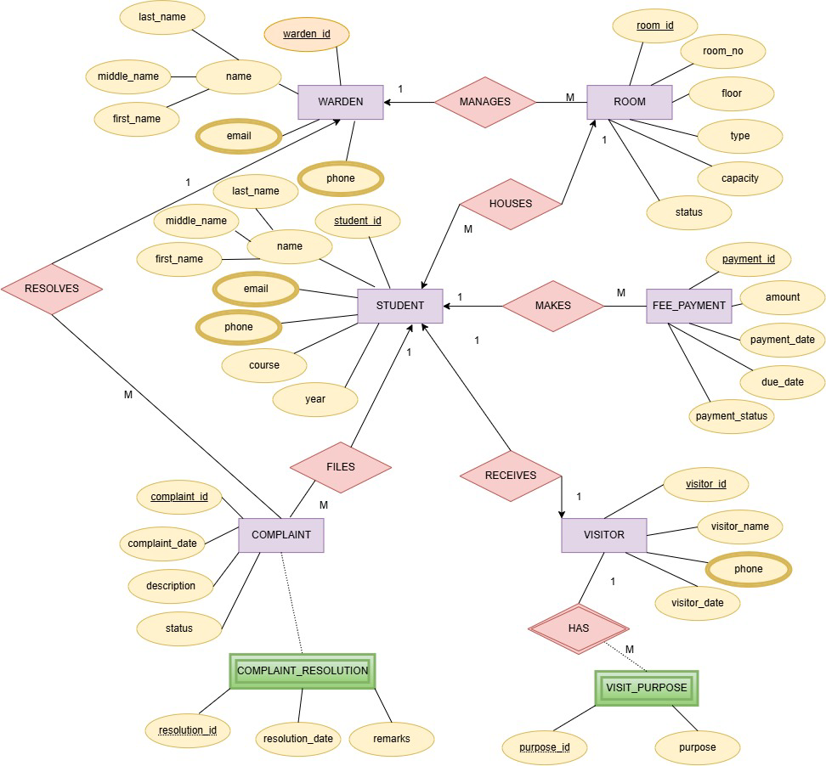
Figure 1: ER representation of the Student Hostel Management System

6. RELATIONAL SCHEMA
Relation | Relational Schema
WARDEN | warden_id (PK), first_name, middle_name, last_name
WARDEN_EMAIL | warden_id (PK/FK), email (PK)
WARDEN_PHONE | warden_id (PK/FK), phone (PK)
ROOM | room_id (PK), room_no, floor, type, capacity, status, warden_id (FK)
STUDENT | student_id (PK), first_name, middle_name, last_name, course, year, room_id (FK)
STUDENT_EMAIL | student_id (PK/FK), email (PK)
STUDENT_PHONE | student_id (PK/FK), phone (PK)
FEE_PAYMENT | payment_id (PK), amount, payment_date, due_date, payment_status, student_id (FK)
COMPLAINT | complaint_id (PK), complaint_date, description, status, student_id (FK), warden_id (FK)
COMPLAINT_RESOLUTION | complaint_id (PK/FK), resolution_id (PK), resolution_date, remarks
VISITOR | visitor_id (PK), visitor_name, visitor_date, student_id (FK)
VISITOR_PHONE | visitor_id (PK/FK), phone (PK)
VISIT_PURPOSE | visitor_id (PK/FK), purpose_id (PK), purpose

7. TABLE DESIGN

7.1 WARDEN
Attribute | Data Type | Constraint | Description
warden_id | INTEGER | PK | Unique warden identifier
first_name | VARCHAR2(30) | — | First name
middle_name | VARCHAR2(30) | — | Middle name
last_name | VARCHAR2(30) | — | Last name

7.2 ROOM
Attribute | Data Type | Constraint | Description
room_id | INTEGER | PK | Unique room identifier
room_no | INTEGER | — | Room number
floor | INTEGER | — | Floor number
type | VARCHAR2(20) | — | Single, Double or Triple
capacity | INTEGER | — | Maximum occupancy
status | NUMBER(1) | — | Room status flag
warden_id | INTEGER | FK | References Warden

7.3 STUDENT
Attribute | Data Type | Constraint | Description
student_id | INTEGER | PK | Unique student identifier
first_name | VARCHAR2(30) | — | First name
middle_name | VARCHAR2(30) | — | Middle name
last_name | VARCHAR2(30) | — | Last name
course | VARCHAR2(30) | — | Academic course/branch
year | INTEGER | — | Year of study
room_id | INTEGER | FK | References Room

7.4 FEE_PAYMENT
Attribute | Data Type | Constraint | Description
payment_id | INTEGER | PK | Unique payment identifier
amount | INTEGER | — | Fee amount
payment_date | DATE | — | Date paid
due_date | DATE | — | Payment due date
payment_status | NUMBER(1) | — | 1 = paid, 0 = pending in supplied data
student_id | INTEGER | FK | References Student

7.5 COMPLAINT
Attribute | Data Type | Constraint | Description
complaint_id | INTEGER | PK | Unique complaint identifier
complaint_date | DATE | — | Date filed
description | VARCHAR2(100) | — | Complaint description
status | NUMBER(1) | — | 1 = resolved, 0 = open in supplied queries
student_id | INTEGER | FK | Student raising complaint
warden_id | INTEGER | FK | Warden handling complaint

7.6 VISITOR
Attribute | Data Type | Constraint | Description
visitor_id | INTEGER | PK | Unique visitor identifier
visitor_name | VARCHAR2(30) | — | Visitor name
visitor_date | DATE | — | Visit date
student_id | INTEGER | FK + UNIQUE | Student being visited

7.7 Child / Relationship Tables
Table | Purpose | Primary Key
STUDENT_EMAIL | Stores student email values | (student_id, email)
STUDENT_PHONE | Stores student phone values | (student_id, phone)
WARDEN_EMAIL | Stores warden email values | (warden_id, email)
WARDEN_PHONE | Stores warden phone values | (warden_id, phone)
VISITOR_PHONE | Stores visitor phone values | (visitor_id, phone)
COMPLAINT_RESOLUTION | Stores complaint resolution history | (complaint_id, resolution_id)
VISIT_PURPOSE | Stores visitor purpose values | (visitor_id, purpose_id)

8. NORMALIZATION
Normalization organizes the tables of a relational database to reduce redundancy and to prevent insertion, update and deletion anomalies. The Student Hostel Management System starts as one flat relation, HOSTEL_RECORD, which is decomposed step by step into First, Second and Third Normal Form. For every step this section shows the relation before decomposition, the problem it contains, and the tables obtained after decomposition, using sample values from the project.

8.1 Unnormalized Form (UNF) — The Problem
All hostel data is first held in one flat table. Repeated data creates redundancy and anomalies.
BEFORE — UNNORMALIZED RELATION
HOSTEL_RECORD(student_id, student_name, phone1, phone2, room_no, room_type, capacity, warden_id, warden_name, warden_phone, amount, due_date, payment_status)
Table 10. UNF sample rows
SID | Student | Phone1 / Phone2 | Room | Warden | Fee
201 | Sai Laxmi | 9100000001 / 9100000002 | 1 | Ravi Sharma | 25000
202 | Rahul Reddy | 9100000003 | 2 | Ravi Sharma | 25000
214 | Manoj Rao | 9100000014 | 14 | Ravi Sharma | 27000
Table 11. Anomalies in the UNF relation
Problem | What goes wrong
Redundancy | Ravi Sharma and the room facts are repeated across many student rows.
Insertion anomaly | A new room cannot be stored until a student exists.
Update anomaly | Changing one warden phone number requires many rows to be updated.
Deletion anomaly | Deleting the last student of a room can make the room information disappear.

8.2 First Normal Form (1NF) — Atomic Values
Rule: remove repeating groups and make every attribute single-valued.
BEFORE — SCHEMA AND SAMPLE
Student(student_id, name, phone1, phone2, email)
Table 12. Student before 1NF
student_id | name | phone1 | phone2
201 | Sai Laxmi | 9100000001 | 9100000002
202 | Rahul Reddy | 9100000003 | —
Problem: phone1 and phone2 form a repeating group. A third phone number would require changing the table structure.
AFTER — 1NF TABLES
Student(student_id, first_name, middle_name, last_name, course, year, room_id FK)
Student_Phone(student_id FK, phone)
Student_Email(student_id FK, email)
Table 13. Student_Phone after 1NF
student_id | phone
201 | 9100000001
201 | 9100000002
202 | 9100000003
Result: each value is atomic; phones can grow without any change to the schema.

8.3 Second Normal Form (2NF) — No Partial Dependency
Rule: 1NF, and every non-key attribute depends on the whole primary key.
BEFORE — PARTIAL DEPENDENCY
Fee_Detail(student_id, payment_id, student_name, course, amount, payment_date)
PK = (student_id, payment_id)
Table 14. Fee_Detail before 2NF
student_id | payment_id | student_name | course | amount
201 | 301 | Sai Laxmi | CSE | 25000
201 | 302 | Sai Laxmi | CSE | 25000
Problem: student_name and course depend only on student_id, which is part of the key — a partial dependency. Student details repeat for every payment.
AFTER — 2NF TABLES
Student(student_id, student_name, course, ...)
Fee_Payment(payment_id, student_id FK, amount, payment_date, due_date, payment_status)
Table 15. Student after 2NF
student_id | student_name | course
201 | Sai Laxmi | CSE
Table 16. Fee_Payment after 2NF
payment_id | student_id | amount | payment_status
301 | 201 | 25000 | 1
302 | 201 | 25000 | 1
Result: student details are stored once; payment facts stay in Fee_Payment.

8.4 Third Normal Form (3NF) — No Transitive Dependency
Rule: 2NF, and every non-key attribute depends only on the primary key.
BEFORE — TRANSITIVE DEPENDENCY
Room(room_id, room_no, floor, type, capacity, status, warden_id, warden_name, warden_phone)
room_id → warden_id → warden_name / warden_phone
Table 17. Room before 3NF
room_id | room_no | warden_id | warden_name
101 | 1 | 1 | Ravi Sharma
102 | 2 | 1 | Ravi Sharma
Problem: warden_name and warden_phone depend on warden_id rather than directly on room_id — a transitive dependency. Warden details repeat for every room the warden manages.
AFTER — 3NF TABLES
Warden(warden_id, first_name, middle_name, last_name)
Room(room_id, room_no, floor, type, capacity, status, warden_id FK)
Table 18. Room after 3NF
room_id | room_no | warden_id
101 | 1 | 1
102 | 2 | 1
Table 19. Warden after 3NF
warden_id | first_name | last_name
1 | Ravi | Sharma
Result: warden details are stored once and linked to rooms through the warden_id foreign key.

8.5 Final Normalized Schema — 3NF
The decomposition removes redundancy while preserving relationships through primary and foreign keys.
Table 20. Flat vs final 3NF schema
BEFORE — FLAT SCHEMA | AFTER — 3NF SCHEMA
HOSTEL_RECORD  Student + Phone + Room + Warden + Fee all stored together  Problems:  → repeated names  → repeated room facts  → anomalies | Warden (warden_id, first_name, middle_name, last_name)  Room (room_id, room_no, floor, type, capacity, status, warden_id FK)  Student (student_id, first_name, middle_name, last_name, course, year, room_id FK)  Fee_Payment (payment_id, amount, payment_date, due_date, payment_status, student_id FK)  Complaint (complaint_id, complaint_date, description, status, student_id FK, warden_id FK)  Visitor (visitor_id, visitor_name, visitor_date, student_id FK)  Student_Phone / Student_Email / Warden_Phone / Warden_Email  Visitor_Phone / Complaint_Resolution / Visit_Purpose
Result: 13 tables — PK/FK relationships enforce referential integrity, redundancy is reduced and the insertion, update and deletion anomalies are removed.

9. SQL IMPLEMENTATION

9.1 DDL — Table Creation
CREATE TABLE room
(
room_id INTEGER,
room_no INTEGER,
floor INTEGER,
type VARCHAR2(20),
capacity INTEGER,
status NUMBER(1),
CONSTRAINT room_pk PRIMARY KEY(room_id)
);
CREATE TABLE fee_payment
(
payment_id INTEGER,
amount INTEGER,
payment_date DATE,
due_date DATE,
payment_status NUMBER(1),
CONSTRAINT fee_payment_pk PRIMARY KEY(payment_id)
);
CREATE TABLE complaint
(
complaint_id INTEGER,
complaint_date DATE,
description VARCHAR2(100),
status NUMBER(1),
CONSTRAINT complaint_pk PRIMARY KEY(complaint_id)
);
CREATE TABLE visitor
(
visitor_id INTEGER,
visitor_name VARCHAR2(30),
visitor_date DATE,
CONSTRAINT visitor_pk PRIMARY KEY(visitor_id)
);
CREATE TABLE warden
(
warden_id INTEGER,
first_name VARCHAR2(30),
middle_name VARCHAR2(30),
last_name VARCHAR2(30),
CONSTRAINT warden_pk PRIMARY KEY(warden_id)
);
CREATE TABLE student
(
student_id INTEGER,
first_name VARCHAR2(30),
middle_name VARCHAR2(30),
last_name VARCHAR2(30),
course VARCHAR2(30),
year INTEGER,
CONSTRAINT student_pk PRIMARY KEY(student_id)
);
The supplied implementation then creates the child tables for multi-valued attributes and adds foreign keys to connect the core entities.
CREATE TABLE student_phone
(
student_id INTEGER,
phone VARCHAR2(15),
CONSTRAINT student_phone_pk PRIMARY KEY(student_id, phone),
CONSTRAINT student_phone_fk FOREIGN KEY(student_id)
REFERENCES student(student_id)
);
CREATE TABLE student_email
(
student_id INTEGER,
email VARCHAR2(50),
CONSTRAINT student_email_pk PRIMARY KEY(student_id, email),
CONSTRAINT student_email_fk FOREIGN KEY(student_id)
REFERENCES student(student_id)
);
CREATE TABLE warden_phone
(
warden_id INTEGER,
phone VARCHAR2(15),
CONSTRAINT warden_phone_pk PRIMARY KEY(warden_id, phone),
CONSTRAINT warden_phone_fk FOREIGN KEY(warden_id)
REFERENCES warden(warden_id)
);
CREATE TABLE warden_email
(
warden_id INTEGER,
email VARCHAR2(50),
CONSTRAINT warden_email_pk PRIMARY KEY(warden_id, email),
CONSTRAINT warden_email_fk FOREIGN KEY(warden_id)
REFERENCES warden(warden_id)
);
CREATE TABLE visitor_phone
(
visitor_id INTEGER,
phone VARCHAR2(15),
CONSTRAINT visitor_phone_pk PRIMARY KEY(visitor_id, phone),
CONSTRAINT visitor_phone_fk FOREIGN KEY(visitor_id)
REFERENCES visitor(visitor_id)
);

9.2 Foreign-Key Alterations
ALTER TABLE room ADD warden_id INTEGER;
ALTER TABLE room ADD CONSTRAINT room_warden_fk
FOREIGN KEY (warden_id)
REFERENCES warden(warden_id);
ALTER TABLE student ADD room_id INTEGER;
ALTER TABLE student ADD CONSTRAINT student_room_fk
FOREIGN KEY (room_id)
REFERENCES room(room_id);
ALTER TABLE fee_payment ADD student_id INTEGER;
ALTER TABLE fee_payment ADD CONSTRAINT payment_student_fk
FOREIGN KEY (student_id)
REFERENCES student(student_id);
ALTER TABLE complaint ADD student_id INTEGER;
ALTER TABLE complaint ADD CONSTRAINT complaint_student_fk
FOREIGN KEY (student_id)
REFERENCES student(student_id);
ALTER TABLE complaint ADD warden_id INTEGER;
ALTER TABLE complaint ADD CONSTRAINT complaint_warden_fk
FOREIGN KEY (warden_id)
REFERENCES warden(warden_id);
ALTER TABLE visitor ADD student_id INTEGER;
ALTER TABLE visitor ADD CONSTRAINT visitor_student_fk
FOREIGN KEY (student_id)
REFERENCES student(student_id);
ALTER TABLE visitor ADD CONSTRAINT visitor_student_uk
UNIQUE(student_id);

9.3 Relationship Tables
CREATE TABLE complaint_resolution
(
complaint_id INTEGER,
resolution_id INTEGER,
resolution_date DATE,
remarks VARCHAR2(100),
PRIMARY KEY (complaint_id, resolution_id),
FOREIGN KEY (complaint_id)
REFERENCES complaint(complaint_id)
);
CREATE TABLE visit_purpose
(
visitor_id INTEGER,
purpose_id INTEGER,
purpose VARCHAR2(50),
PRIMARY KEY (visitor_id, purpose_id),
FOREIGN KEY (visitor_id)
REFERENCES visitor(visitor_id)
);

9.4 Sample Data
The supplied code loads 15 rows into each core table and associated child/relationship tables. The PPT reports more than 200 records across the 13 tables.
INSERT INTO warden VALUES
(1, 'Ravi', 'Kumar', 'Sharma');
INSERT INTO room VALUES
(101, 1, 1, 'Single', 1, 1, 1);
INSERT INTO student VALUES
(201, 'Sai', 'Sri', 'Laxmi', 'CSE', 2, 101);
INSERT INTO fee_payment VALUES
(301, 25000, DATE '2026-01-05',
DATE '2026-01-10', 1, 201);
INSERT INTO student_phone VALUES
(201, '9100000001');

9.5 Sample Record Counts
Table | Records in supplied project
Warden | 15
Room | 15
Student | 15
Fee_Payment | 15
Complaint | 15
Visitor | 15
Student_Email / Student_Phone | 15 each
Warden_Email / Warden_Phone | 15 each
Visitor_Phone | 15
Complaint_Resolution | 15
Visit_Purpose | 15

10. SQL QUERIES AND OUTPUTS
The supplied SQL contains 15 application-oriented queries. They demonstrate single-table selection, joins, filtering, LEFT JOIN, GROUP BY, HAVING, COUNT, SUM, ordering, and complaint/visitor reporting.

Q1. Display all students
Purpose / concept: Returns the complete student register.
SELECT *
FROM student;

Q2. Student with room
Purpose / concept: Uses an INNER JOIN between Student and Room.
SELECT s.student_id,
s.first_name || ' ' || s.last_name AS student_name,
s.course, s.year,
r.room_no, r.floor, r.type
FROM student s
JOIN room r
ON s.room_id = r.room_id;

Q3. Students belonging to CSE
Purpose / concept: Filters students using WHERE.
SELECT student_id, first_name, last_name,
course, year
FROM student
WHERE course = 'CSE';

Q4. Rooms managed by each warden
Purpose / concept: Joins Warden and Room and sorts by warden.
SELECT w.warden_id,
w.first_name || ' ' || w.last_name AS warden_name,
r.room_no, r.floor, r.type
FROM warden w
JOIN room r
ON w.warden_id = r.warden_id
ORDER BY w.warden_id;

Q5. Students who have paid
Purpose / concept: Shows paid fee records; status 1 is paid in the supplied data.
SELECT s.student_id,
s.first_name || ' ' || s.last_name AS student_name,
f.amount, f.payment_date, f.payment_status
FROM student s
JOIN fee_payment f
ON s.student_id = f.student_id
WHERE f.payment_status = 1;

Q6. Pending fee payments
Purpose / concept: Shows students whose fee status is pending.
SELECT s.student_id,
s.first_name || ' ' || s.last_name AS student_name,
f.amount, f.due_date
FROM student s
JOIN fee_payment f
ON s.student_id = f.student_id
WHERE f.payment_status = 0;

Q7. Complaint details
Purpose / concept: Three-table join for complaint tracking.
SELECT c.complaint_id,
s.first_name || ' ' || s.last_name AS student_name,
c.description, c.complaint_date, c.status,
w.first_name || ' ' || w.last_name AS warden_name
FROM complaint c
JOIN student s ON c.student_id = s.student_id
JOIN warden w ON c.warden_id = w.warden_id;

Q8. Unresolved complaints
Purpose / concept: Filters open complaints; status 0 is open in the supplied queries.
SELECT complaint_id, student_id,
description, complaint_date
FROM complaint
WHERE status = 0;

Q9. Count students in each room
Purpose / concept: LEFT JOIN keeps rooms even when they have no student.
SELECT r.room_no,
r.capacity,
COUNT(s.student_id) AS students_count
FROM room r
LEFT JOIN student s
ON r.room_id = s.room_id
GROUP BY r.room_no, r.capacity
ORDER BY r.room_no;

Q10. Rooms with available capacity
Purpose / concept: Uses GROUP BY and HAVING to identify free beds.
SELECT r.room_no,
r.capacity,
COUNT(s.student_id) AS occupied,
r.capacity - COUNT(s.student_id) AS available
FROM room r
LEFT JOIN student s
ON r.room_id = s.room_id
GROUP BY r.room_no, r.capacity
HAVING COUNT(s.student_id) < r.capacity;

Q11. Count students in each course
Purpose / concept: Aggregates hostel strength by course.
SELECT course,
COUNT(*) AS total_students
FROM student
GROUP BY course
ORDER BY total_students DESC;

Q12. Total fee collected
Purpose / concept: Calculates collected fees; the supplied output reports 329000.
SELECT SUM(amount) AS total_fee_collected
FROM fee_payment
WHERE payment_status = 1;

Q13. Visitor log
Purpose / concept: Produces a chronological visitor log.
SELECT v.visitor_id, v.visitor_name,
v.visitor_date,
s.student_id,
s.first_name || ' ' || s.last_name AS student_name
FROM visitor v
JOIN student s
ON v.student_id = s.student_id
ORDER BY v.visitor_date;

Q14. Visitors per student
Purpose / concept: Counts visitor records per student.
SELECT s.student_id,
s.first_name || ' ' || s.last_name AS student_name,
COUNT(v.visitor_id) AS visitor_count
FROM student s
JOIN visitor v
ON s.student_id = v.student_id
GROUP BY s.student_id, s.first_name, s.last_name
ORDER BY visitor_count DESC;

Q15. Complaint resolutions
Purpose / concept: Joins complaints to their resolution history.
SELECT c.complaint_id, c.description,
cr.resolution_date, cr.remarks
FROM complaint c
JOIN complaint_resolution cr
ON c.complaint_id = cr.complaint_id
ORDER BY cr.resolution_date;

10.1 Key Outputs from the Supplied Data
Query / Measure | Supplied Result
CSE students | 7 students
Paid fee records | 13 students
Pending fee records | 2 students
Total fee collected | 329,000
Outstanding dues | 52,000 across 2 students
Open complaints | 4 complaints
Course distribution | CSE 7, IT 3, AIML 3, ECE 2
Rooms with free beds | 10 rooms identified by the supplied HAVING query
Visitors | 15 visitor records
Complaint resolutions | 15 resolution records

The outputs above are taken from the supplied presentation/code. The exact displayed rows may depend on the state of the Oracle database when the queries are executed.

11. CONCLUSION
The Student Hostel Management System converts common hostel administration activities into a structured relational database. The supplied implementation separates core entities from multi-valued and repeating facts, uses primary and foreign keys for referential integrity, and applies normalization through 1NF, 2NF and 3NF.
The SQL implementation demonstrates practical DBMS concepts including DDL, ALTER TABLE, primary keys, foreign keys, UNIQUE constraints, composite keys, INSERT statements, JOIN operations, GROUP BY, HAVING, COUNT and SUM. The query set provides reports for room allocation, fee status, complaints, course distribution and visitor tracking.

12. FUTURE ENHANCEMENTS
- Role-based access for administrators, wardens, students and security staff.
- Automatic room-allocation procedure or trigger based on available capacity.
- Attendance, leave and hostel-exit management.
- Fee reminders, scholarships and online payment integration.
- Timetable and facility/service management.
- Automated dashboards for occupancy, dues and complaint status.
- Backup, recovery and audit logging.
- Web or mobile interface connected to the Oracle database.

13. REFERENCES
- Silberschatz, A., Korth, H. F., & Sudarshan, S., Database System Concepts, 7th Edition, McGraw-Hill Education, 2020.
- Elmasri, R., & Navathe, S. B., Fundamentals of Database Systems, 7th Edition, Pearson.
- Oracle Corporation, Oracle Database SQL Language Reference, Oracle Database 21c Documentation.
- Oracle Corporation, Oracle Database SQL Language Reference, Oracle Database 19c Documentation.
- Oracle Corporation, Oracle Database Documentation, Oracle Database Technical Documentation.
- Coronel, C., & Morris, S., Database Systems: Design, Implementation, & Management, Cengage Learning.
- Date, C. J., An Introduction to Database Systems, Pearson.

APPENDIX A — STATUS VALUES USED IN SUPPLIED QUERIES
Field | Value | Meaning in supplied project
fee_payment.payment_status | 1 | Paid
fee_payment.payment_status | 0 | Pending
complaint.status | 1 | Resolved
complaint.status | 0 | Open
room.status | 1 / 0 | Room status flag; the supplied data uses both values.

APPENDIX B — PROJECT TEAM
- Nunna Sai Sri Laxmi — 25B11CS682
- Kamuju Sree Reshma Laxmi — 25B11CS385
- Bheemireddy Aswini — 25B11CS107
- Medepalli Akshaya Keerthana — 25B11CS592

